Tên: Hồ Chí Nguyên

MSSV: 2251050048

QUẢN TRỊ MẠNG

BÀI THỰC HÀNH BUỔI 1

2.

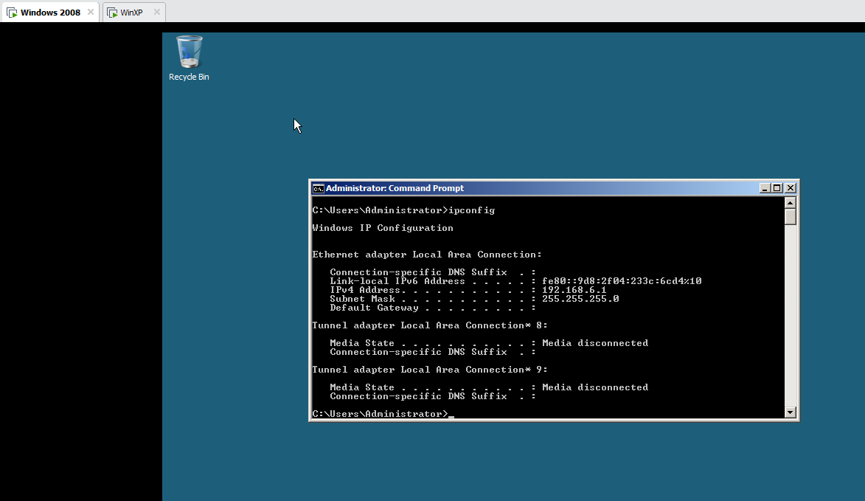

3.

4.

5.

6.

